PROJECT KIT PHOTOGRAPHY FOR GAS LEAKAGE MONITORING AND ALERTING SYSTEM FOR INDUSTRIES

[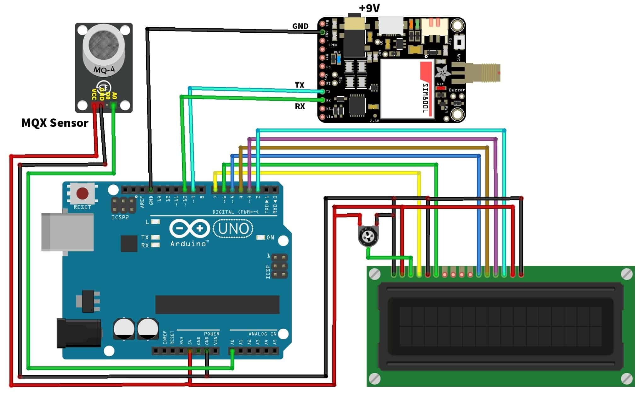](https://how2electronics.com/wp-content/uploads/2019/05/Circuit-Diagram.jpg)